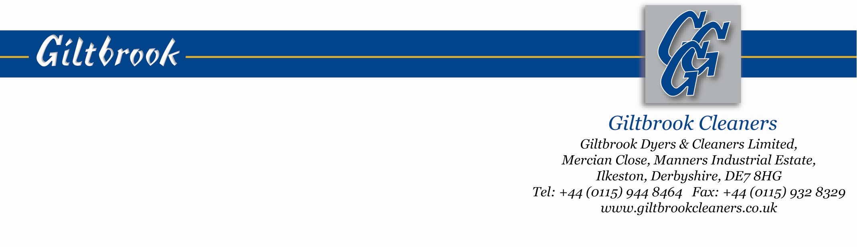
EQUAL OPPORTUNITIES MONITORING FORM

Giltbrook Cleaners seeks to create a culture of employment and service delivery through its managers and other employees in which people can feel confident about being treated with fairness, dignity and tolerance irrespective of their personal circumstances, back ground or lifestyle.

To help us work towards the success of our policies, we ask that all people complete this form when applying for employment with us. This form is kept separate from the main application form and is not seen by the manager involved in short listing for interview. The questions relating to disability and particular special requirements are asked in order that proper arrangements can be made when planning interviews and to help proper discussion of possible job needs at interview. Other information is used for summary purposes only and is produced in a way that will not identify you as an individual.

On the understanding of the above, it would be of help if you were to give the following information:

Job applied for ………………………………………………………………………….Ref No……………

Surname……………………………………………………………………………………………………….

First names…………………………………………………………………………………………………….

I would describe myself as having a disability Yes No

Special requirements that may be necessary to attend interview are:-

Special requirements that may be necessary for me to carry out the defined job are:-

Please tick appropriate choice:-
Male Single Divorced/separated
Female Married (or with partner) Widow/widower

Current age 16-20 21-25 26-30 31-35 36-40 Date of birth
41-45 46-50 51-55 56-60 61-65 ……………..

I have a responsibility for caring for dependant children (under 16) Yes No

I have a responsibility for caring for other dependant relatives Yes No

I consider my racial/cultural background to be:-
BLACK African ASIAN/BLACK Chinese WHITE European (not UK) OTHER Please state
Afro-Caribbean Indian Irish
UK Pakistani UK
Bangladeshi
UK

